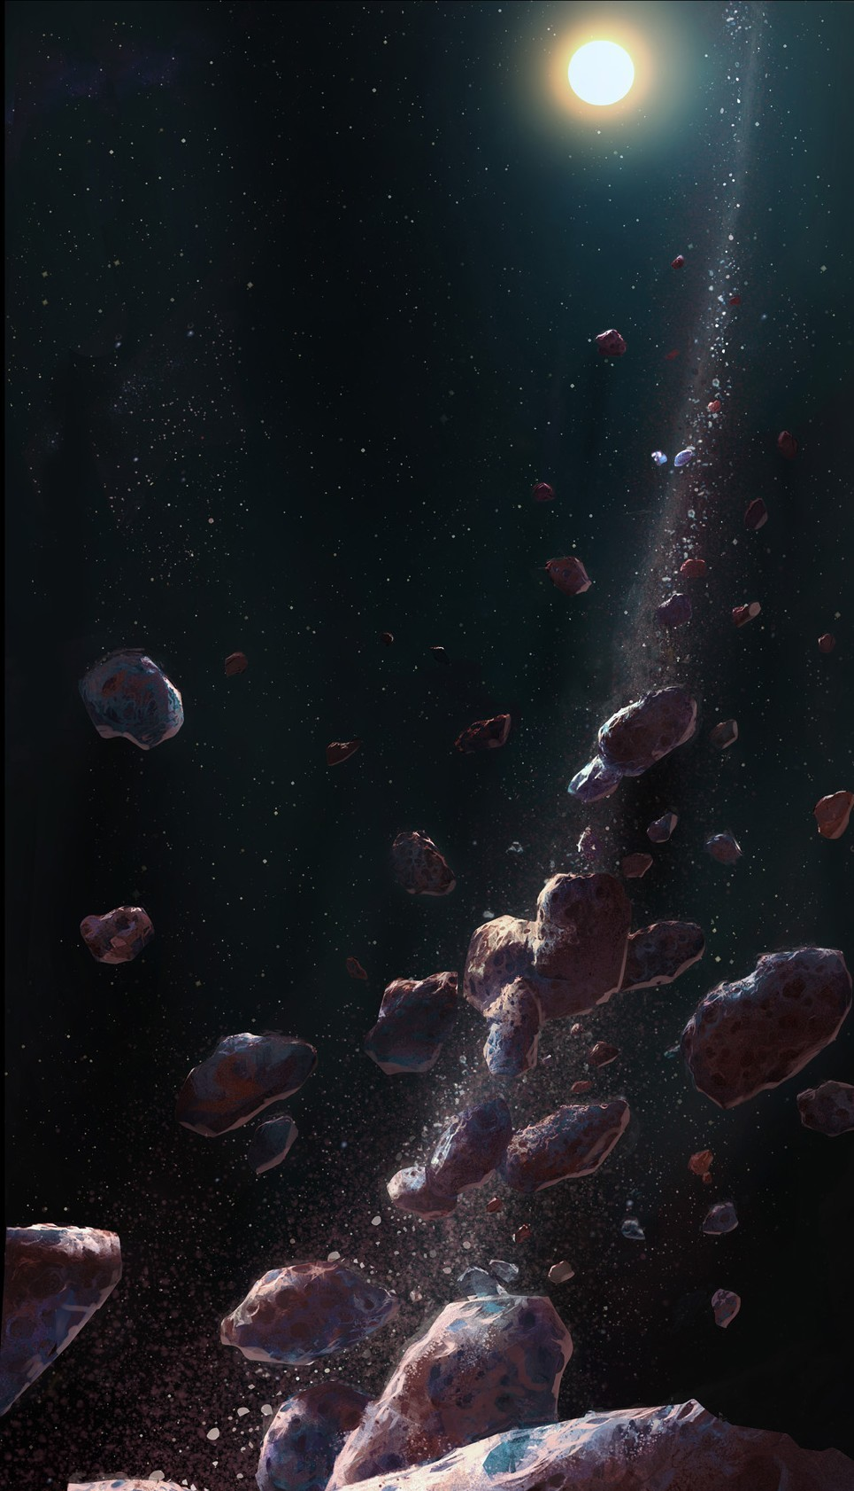TEMPEL

Contents

introduction 3

Factions 3

The beginning 3

Mechanics 3

Gameplay 3

# introduction

Tempel is not a game.

It is a grown-ass mother-of-all-simulation-games epicly concentrated ball of unrivalled complexity, in a universe filled with spaceships, aliens, weapons of mass destruction, robots, wooooah-esque moments and even alien robots. Featuring a development time longer than your great-grand-father’s lifetime.

# Factions

// Factions description / Few pages

# The beginning

// Beginning of a game description / Few pages

# Mechanics

// Game mechanics, a lot of them, explained in details / Frickin’ lotta pages

// Among them : Resources harvesting, Navigation, Sensors, Combat, Research, Diplomacy, Progression, Random events, Population, Ship management, Base management, Space stations, Trading, etc…

# Gameplay

// What the player does, to what extent he influences the factions // Few pages